**Daily Scrum or Standup Meeting**

Team name: Team 08

Scrum Master: Tristan Thomas

Date:Oct 30

|  |  |  |  |
| --- | --- | --- | --- |
| **Team Member** | **What did you do since the last Scrum?** | **What do you plan to do before the next scrum?** | **What obstacles do you have?** |
| Hannah Howell | Implemented the beginnings of a hamburger menu | Finish the hamburger menu  After items can be added, make it so items can be viewed by bidders | -Ethics video is quite long |
| Garrett Johnson | Made auction creation page  Made auction detail page | Implement silent and live sections for an auction  Implement start and end auction | Ethics video |
| Zion Steiner | * Merged auth branch into master | * Implement users/admins to view item info | * Ethics video |
| Tristan Thomas | * Updated UI for sign up, login, account, edit account, and password changed pages. | * Create item view page | * Ethics video and quiz |
| N/A |  |  |  |

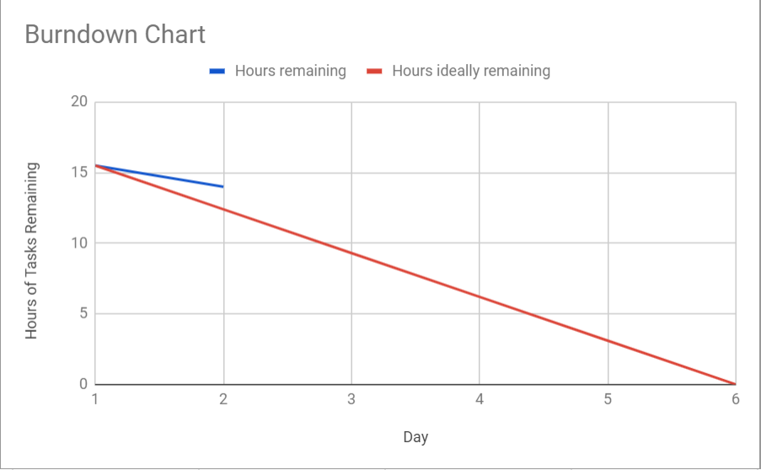

# Screenshot of your project board

